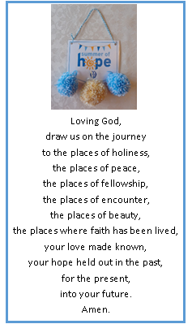
Thoughts from your President, Maxine Paul
Well, I did it! I visited every church where a branch meets and quite a few extra churches where the branch represents more than one parish such as Billericay – 48 in total! And, what a wonderful time I’ve had doing it – meeting members, capturing pictures with banners, finding out about some really interesting churches and hearing about all the wonderful restorations (Rayleigh) and reordering going on... In the process, I think I attended at least 12 cream teas, garden parties or lunches and one branch (Elm Park) even had four banners! I also got to hear about how you run your branches, the sort of support you might need in the future, how you’ve been using the “Transformation – Now!” prayer and seeing hope turned into action at the food hubs and community cafes at two of the churches (Hutton and Highams Park).
There were a few churches where I was unable to meet anyone, but if the churches were open, I still managed a photo with the banner. If I missed you completely, perhaps you could take a photo of yourselves with your banner and pompoms to send me please and book me to come to one of your meetings later in the year.
I raised just over £850 in sponsorship and branches sent us another £600+ raised in other ways for the “Summer of Hope” campaign and it’s possible that more went straight to Mary Sumner House. This will be used by the team there to support dioceses in their work with AFIA, prisons and parenting. I also made over 200 pompoms to distribute with love and the SoH prayer. Thank you one and all for contributing and making me so welcome wherever I went.
At the side, I have shared a prayer from a little card for the “2020 Year of Cathedrals, Year of Pilgrimage” which I was given at Harlow Common Branch and summed up my little “pilgrimage” around CDMU branches.
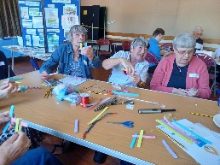
I very much enjoyed leading the Mary Sumner Day members’ event at Witham helped by Rev Jane Quinton (Assoc. Priest, Witham & Villages), Rev Stephen Northfield (Witham Deanery Chaplain), Rev Michael Hatchett (Copford Branch Leader) and Curate Noah Cockett – I’m not too sure everyone got quite the same pleasure out of making pompoms as I have done or making St Brigid’s Crosses, though! Thank you to the hosts for making us all so welcome. I also gave a talk about Mothers’ Union at All Saints, Woodford Wells Vintage Lunch as a result of my SoH visit there. So, I have had an August drenched in MU!
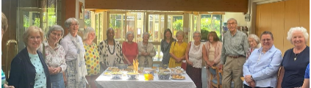
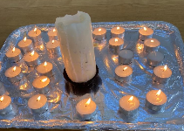
Thanks to Merrill, Pauline and team at Billericay who also led a well-attended Mary Sumner Day Service and lunch.
Love and blessings. Maxine x

PS. You can still sponsor me via https://www.justgiving.com/page/maxine-paul-1687445214184

English for Women fundraising concert: Two Lads and a Laptop
What’s this all about? Well, they are two musicians, armed with various strings, things and a Laptop, on a mission to spread love, joy and peace through music! Using popular show tunes, A Million Dreams explores the ‘rags to riches’ narrative and then turns it on its head. True wealth, true riches are not to be found through our dreams, but through our heart’s response to a loving God. A bit classical, a bit modern with the shows, humour and faith thrown in – what better entertainment for a Saturday night out?! At Emmanuel Church, Billericay 7pm on 7th October. Anyone is welcome, so tell your friends and neighbours or put it in your parish mags. Tickets can be ordered online at Live at Emmanuel: Two Lads and a Laptop! – revPACman or in person from Treasurer Tricia, VP Merrill, or Secretary Kathryn. Tickets are priced at £15 (£1 online booking fee).

Consultation on new diocesan constitution
Our new draft constitution and regulations will be presented at the AGM on 13th November. The draft has been circulated to all branch contacts and to members on email. Members can submit questions and comments for consideration by Trustees until 1st October.

The Wave of Prayer
You can now follow the diocesan wave of prayer on our Facebook page. Prayers are also posted weekly on our branch leaders and our diocesan members WhatsApp groups. Please contact the diocesan secretary if you would like to be added to either of these groups.
Please note, Midday prayers are no longer available on the Daily Hope phone line but continue to be posted daily on the central Mothers’ Union Facebook page.

News from Mary Sumner House
The annual gathering in York takes place on Friday 22nd September. For more information visit https://www.mothersunion.org/annual-gathering-2023. Tickets available until 8th September. Some CDMU members are travelling up together so please let us know if you are planning to attend. Send your mobile number to Secretary Kathryn who will set up a WhatsApp Group so we can keep in touch and, hopefully, secure seats together.
The new Christmas & Autumn/Winter 2023 Gift Guide is now available. Visit https://mueshop.org to see the many new gifts and cards available, including the new range of Christmas cards. Place your order for diaries, planners, calendars and cards with Secretary Kathryn (or email MUerep@muchelmsford.org.uk ) if you are able to collect them at the AGM in November.
For regular updates on central MU work, sign up to the central e-newsletter on this link: https://mothersuniononline.org/p/1I8Y-G0K/sign-up-to-the-mothers-union-mailing-list

Literacy week – the Burundi project
8th September is International Literacy Day and this year it is a great opportunity to celebrate Mothers’ Union literacy programmes, in particular 20 years of the Literacy and Financial Education programme in Burundi. The astonishing impact of this programme has been captured in the Burundi report available at Burundi Report | Mothers' Union (mothersunion.org). Members can now directly support the literacy programmes with a “Literacy For Life” Gift available at Literacy for Life – Mothers' Union Shop (mueshop.org).

Understanding County Lines for Parents, Grandparents and Guardians
County lines is becoming one of the most prevalent forms of modern slavery, affecting children and vulnerable adults across the country. The Clewer Initiative are offering an awareness raising session aimed at parents, grandparents and guardians of children and young people. The session will cover:
- What is county lines?
- Why should parents/grandparents/guardians be aware of the issue?
- How can we spot the signs?
- What can we do about county lines and how can we talk to our children about it?
The session will take place on 19th October 10:00-11:00. If you would like to attend, please sign up using the link here https://www.eventbrite.co.uk/e/671386112937?aff=oddtdtcreator

November Roundabout – copy deadline
The deadline for articles for the next edition of Roundabout is 1st October. Please send articles to roundabout@muchelmsford.org.uk

Dates for the dairy

- Annual gathering: Friday 22nd September
- Two Lads and a Laptop concert: 7th October 7pm, Emmanuel Church, Billericay.
- AGM and Council: 13th November, Chelmsford Cathedral

